**Rui Carapinha Artificial Intelligence**

**248728 Bayesian Belief Networks**

**3.**

In this part of the report I made several networks with different subsets of the dataset. The network with: weathersit, windspeed, hum, mnth, season, atemp, temp, registered, workingday, weekday, cnt, casual

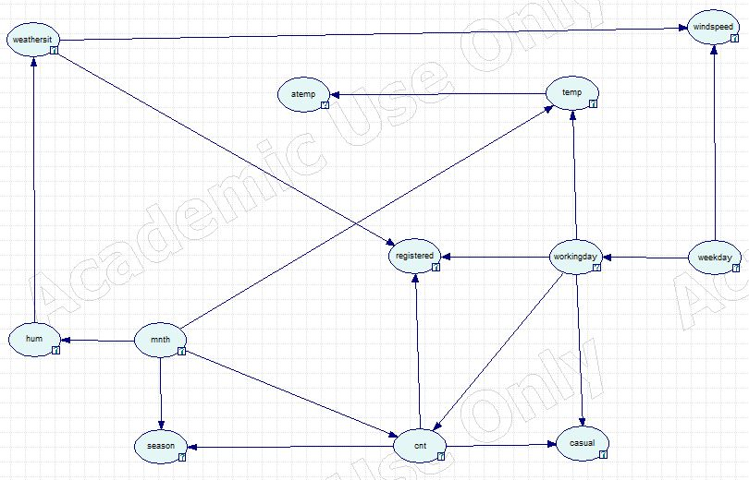

Network with: weathersit, windspeed, hum, atemp, temp, registered, workingday, cnt, casual

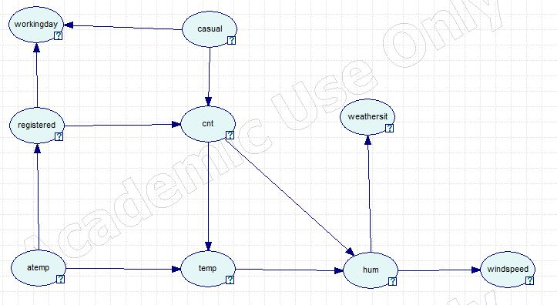

Network with: weathersit, windspeed, hum, atemp, temp, registered, workingday, holiday, cnt, casual

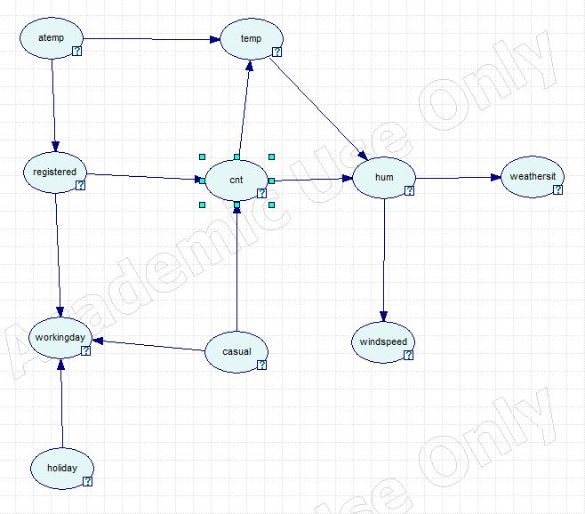

Network with: weathersit, windspeed, hum, atemp, temp, registered, cnt, casual

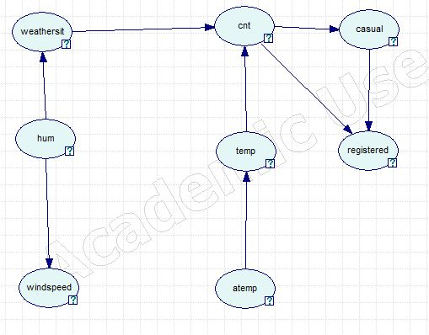

**4.** The network built in the AISPACE tool was the following:

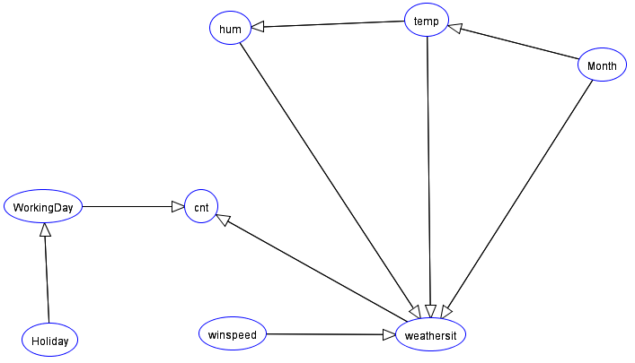

When we make the observation that the month is between 2-8, we get the following result:

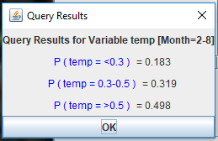

We can check that the temperatures are higher here, as expected because in this month we have the Summer, Spring and Fall that are hotter than the Winter.

**5.** The decision node I added was “Should I go for a run?” this decision node depends on the temperature and if it’s a working day or not. The network looks like this now:

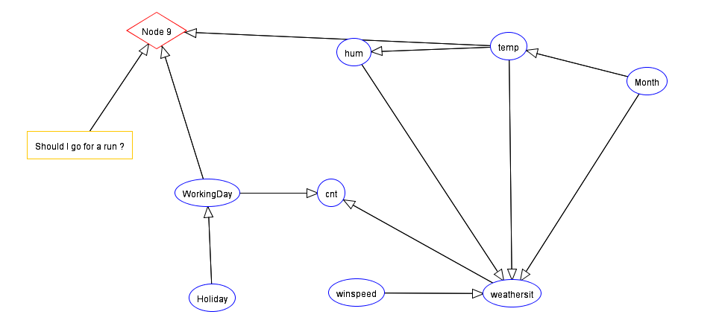

The decision table for the “Should I go for a run?” node is the following:

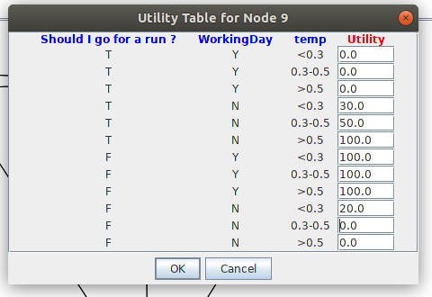

In this utility table I choose to always run if it isn’t a working day.

To obtain the decision made by our network when we set the Working_Day to True we obtain following:

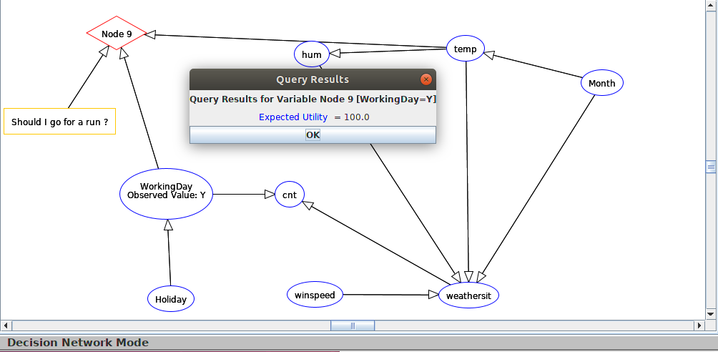

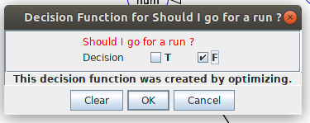

As we can see the decision our network makes is to not go running because it’s a working day. This decision is expected according to the utility node distribution.